These are the IPAD APPS used in math support class. Please use these at home over the summer. These were FREE.
Most of these apps can be used on an iPAD, iPOD, or iPHONE.

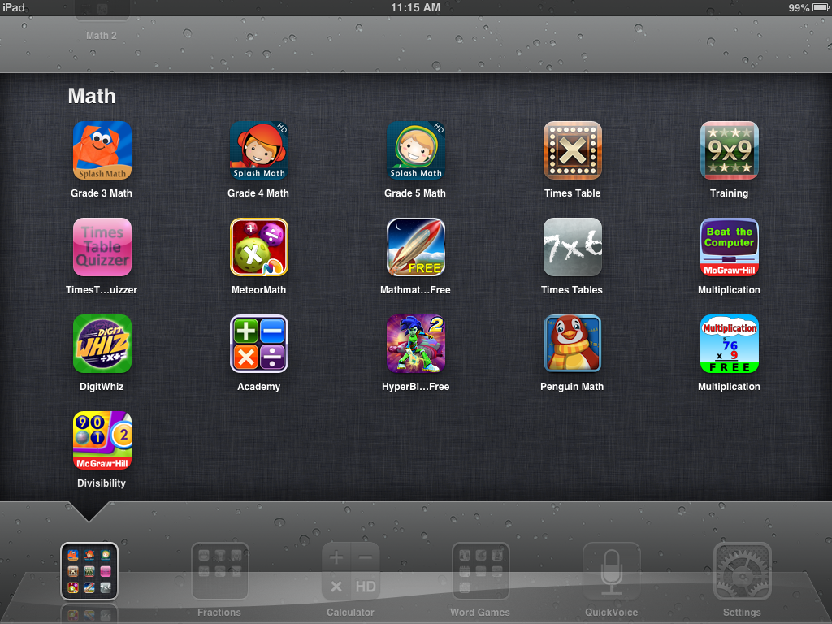

Apps by Title and Who publishes them:

Splash Math by StudyPad, Inc.
Times Table by The App Gate
Multiplication Training by The App Gate
Times Table Quizzer – no longer on the app store
MeteorMath by Mindshapes
Mathmateer Free by Dan Russell-Pinson
Times Tables by Koalapps
Beat the Computer by McGraw-Hill
DigitWhiz by DigitWhiz Inc = also online at www.digitwhiz.com
Academy by The App Gate
Math Blaster HyperBlast 2 by Knowledge Adventure
Penguin Math by Pilot Fish Media
Multiplication by Horizon Business, Inc.
Divisibility by McGraw-Hill
QuickVoice by nFinity Inc = for saying/listening to multiplication facts songs

Other Math apps to practice fractions, addition and subtraction:



